Data Set 1
ELAI_CLIENT_LOG:
The ELAI_CLIENT_LOG is a consolidated version of two types of files,
- The log pre – total 7 Files.
- The log sessions – Total 5 Files.
The consolidated file has Time stamp and the details about ELAI Pull and ELAI Push.
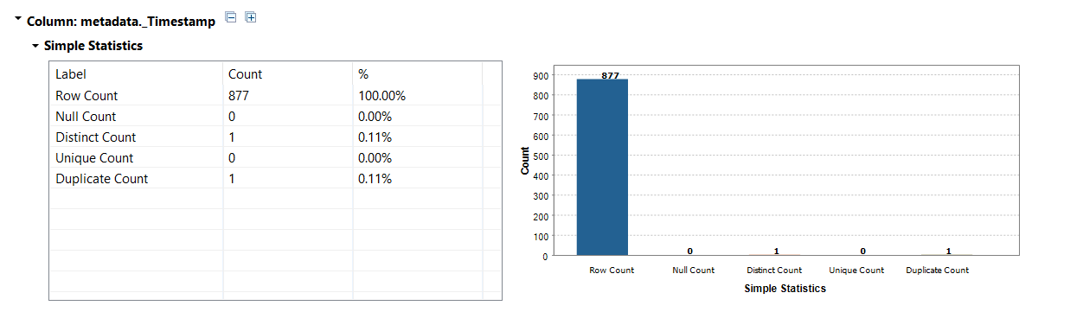
We can see below the number counts when Pull & Push were implemented.
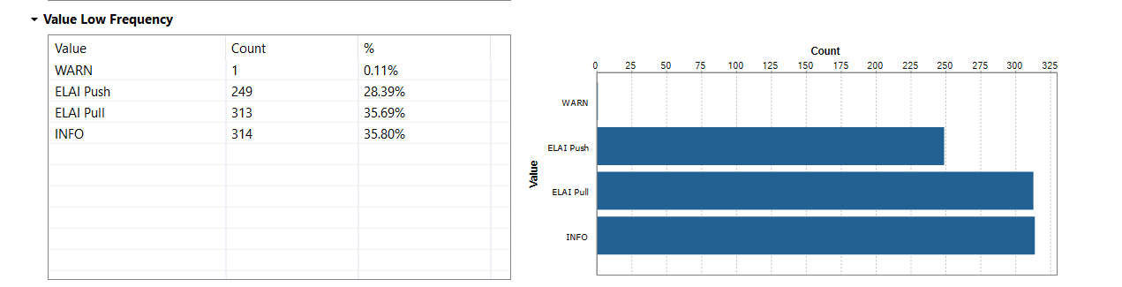
ELAI Pull:
Below is the extract of the same,
{"learnerNeedHelp":false,"learnerNeedHelp_new":false,"genreName":"http://iosb.fraunhofer.de/ias/ibis/elai/xapidefinitions/activity/game/Seek-and-Find_Game/","skillLevel":0.5,"learnerNeedHelp_old":false,"helpingLevel":0.5}

The ELAI Pull carries the following information,

learnerNeedHelp: false/true
learnerNeedHelp_new/learnerNeedHelp_old: false/true
genreName:
skillLevel:
helpingLevel:

ELAI Push
Below is the extract of the same,
{"actor":{"objectType":"Agent","name":"T01","mbox":"T01@leidig.msc"},"verb":{"id":"http://iosb.fraunhofer.de/ias/ibis/elai/xapidefinitions/verb/played/","display":{"en-US":"played"}},"object":{"objectType":"Activity","id":"http://iosb.fraunhofer.de/ias/ibis/elai/xapidefinitions/activity/task/findTheTankT42/","definition":{"name":{"en-US":"Find the tank T-42"}}},"result":{"duration":"PT7.4517451S","score":{"scaled":1.0},"extensions":{"http://iosb.fraunhofer.de/ias/ibis/elai/xapidefinitions/distanceToTarget":0.782196044921875}},"context":{"contextActivities":{"parent":[{"objectType":"Activity","id":"http://iosb.fraunhofer.de/ias/ibis/elai/xapidefinitions/activity/task/","definition":{"name":{"en-US":"task"}}}],"grouping":[{"objectType":"Activity","id":"http://iosb.fraunhofer.de/ias/ibis/elai/xapidefinitions/activity/game/Seek-and-Find_Game/","definition":{"name":{"en-US":"Seek-and-Find Game"}}}]}},"version":"1.0.1"}

The ELAI Push carries the following major information,
verb:
objectType:
duration:
score:
distanceToTarget:

Data Set 2
ELAI_LOG
The ELAI_LOG is a consolidated version of two types of files,
- The log pre – total 7 Files.
- The log sessions – Total 5 Files.

The total log is 16159 Rows and 7 columns
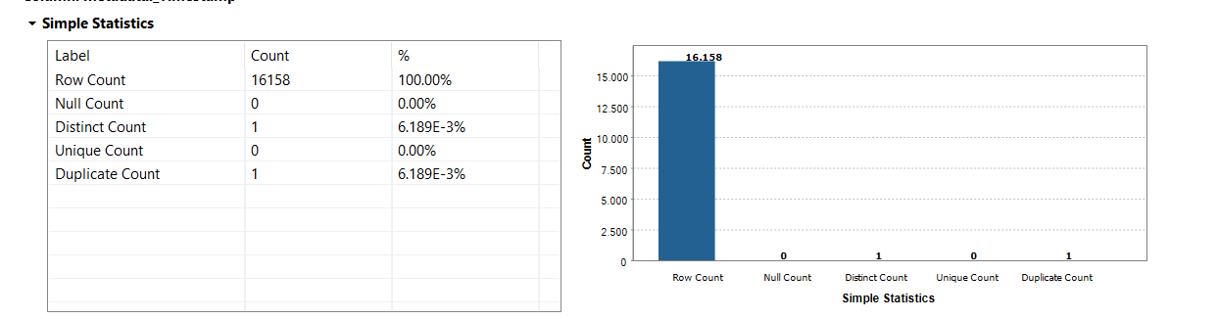

Listed below is the category wise count.
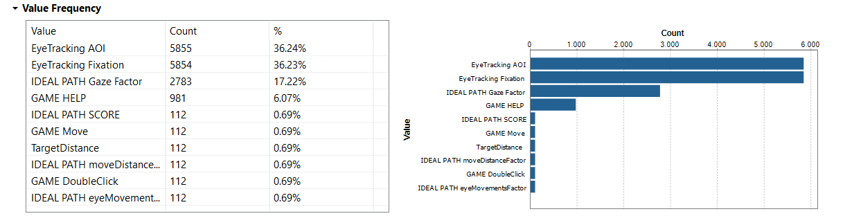
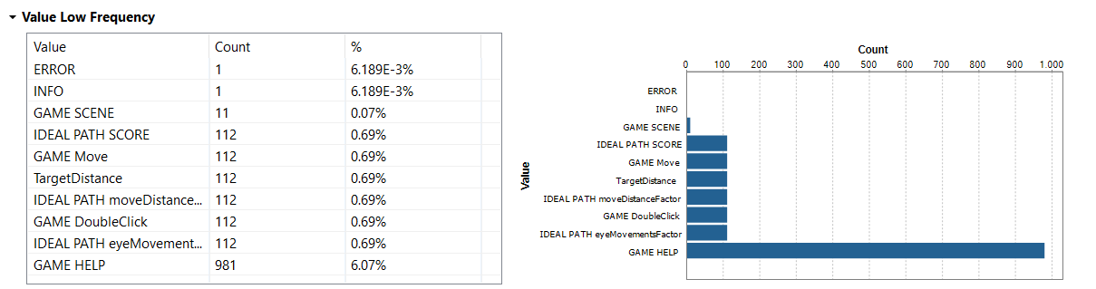
The column under category gives the following information,
EyeTracking Fixation
EyeTracking AOI
GAME DoubleClick
GAME HELP
GAME Move
GAME SCENE
IDEAL PATH eyeMovementsFactor
IDEAL PATH Gaze Factor
IDEAL PATH moveDistanceFactor
IDEAL PATH SCORE
TargetDistance

